**1.*Write a query which will display the customer id, account type they hold, their account number and bank name.**

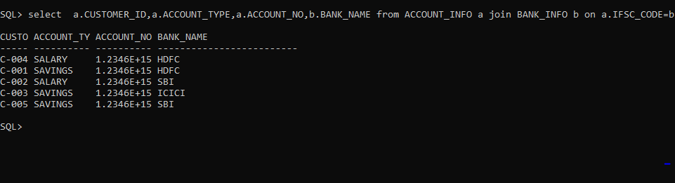select a.CUSTOMER_ID,a.ACCOUNT_TYPE,a.ACCOUNT_NO,b.BANK_NAME from ACCOUNT_INFO a join BANK_INFO b on a.IFSC_CODE=b.ISFC_CODE;

**2. Write a query which will display the customer id, account type and the account number of HDFC customers who registered after 12-JAN-2012 and before 04-APR-2012.**

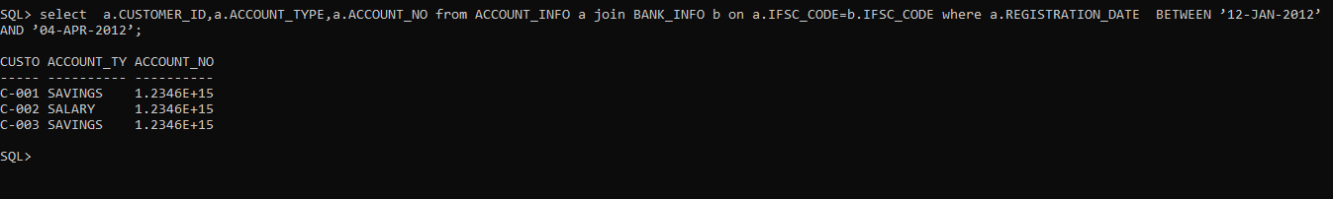select a.CUSTOMER_ID,a.ACCOUNT_TYPE,a.ACCOUNT_NO from ACCOUNT_INFO a join BANK_INFO b on a.IFSC_CODE=b.IFSC_CODE where a.REGISTRATION_DATE BETWEEN ’12-JAN-2012’ AND ’04-APR-2012’;

3**.*Write a query which will display the customer id, customer name, account no, account type and bank name where the customers hold the account.**

select c.CUSTOMER_ID ,c.CUSTOMER_NAME,a.ACCOUNT_NO,a.ACCOUNT_TYPE,b.BANK_NAME from CUSTOMER_PERSONAL_INFO c join ACCOUNT_INFO a on c.CUSTOMER_ID=a.CUSTOMER_ID join BANK_INFO b on b.IFSC_CODE=a.IFSC_CODE;

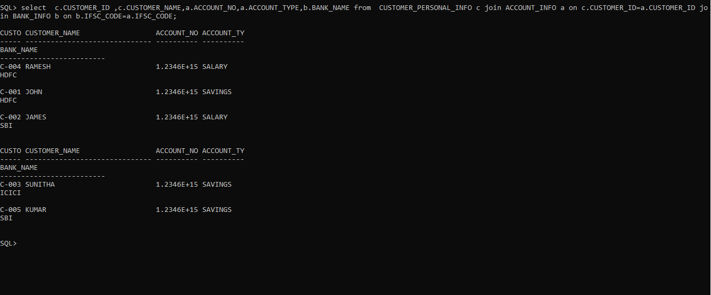

**4.*Write a query which will display the customer id, customer name, gender, marital status along** **with the unique reference string and**

**sort the records based on customer id in descending order. <br/>**

**<br/><b>Hint: </b>Generate unique reference string as mentioned below**

**:**

**<br/> CustomerName_Gender_MaritalStatus**

**<br/><b> Example, </b>**

**<br/> C-005 KUMAR M SINGLE KUMAR_M_SINGLE**

**<BR/>**

**Use ""UNIQUE_REF_STRING"" as alias name for displaying the unique reference string."**

select CUSTOMER_ID,CUSTOMER_NAME,GENDER,MARITAL_STATUS,(CUSTOMER_NAME || ‘_’|| GENDER || ’_’ || MARITAL_STATUS) as UNIQUE_REF_STRING from CUSTOMER_PERSONAL_INFO order by CUSTOMER _ID desc;

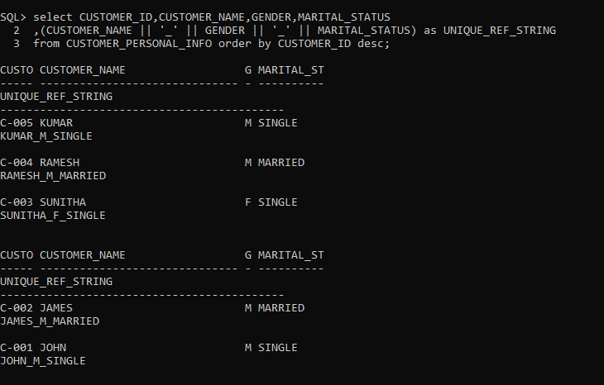

**5.*Write a query which will display the account number, customer id, registration date, initial deposit amount of the customer**

**whose initial deposit amount is within the range of Rs.15000 to Rs.25000.**

select ACCOUNT_NO,CUSTOMER_ID,REGISTRATION_DATE,INITIAL_DEPOSIT from ACCOUNT_INFO where INITIAL DEPOSIT between 15000 and 25000;

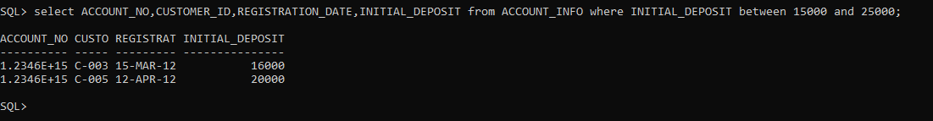

**6.*Write a query which will display customer id, customer name, date of birth, guardian name of the customers whose name starts with 'J'.**

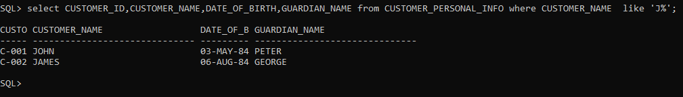select CUSTOMER_ID,CUSTOMER_NAME,DATE_OF_BIRTH,GUARDIAN_NAME from CUSTOMER_PERSONAL_INFO where CUSTOMER_NAME like ‘J%’;

7. **\*Write a query which will display customer id, account number and passcode.**

**<br/>**

**Hint: To generate passcode, join the last three digits of customer id and last four digit of account number.**

**<br/>Example**

**<br/>C-001 1234567898765432**

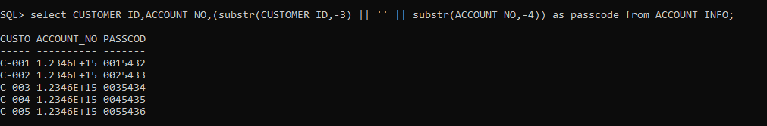select CUSTOMER_ID,ACCOUNT_NO , (substr(CUSTOMER_ID,-3) || ‘’ || substr(ACCOUNT_NO,-4) as passcode from ACCOUNT_INFO;

**8.*Write a query which will display the customer id, customer name, date of birth, Marital Status, Gender, Guardian name,**

**contact no and email id of the customers whose gender is male 'M' and marital status is MARRIED.**

select CUSTOMER_ID,CUSTOMER_NAME,DATE_OF_BIRTH,MARITAL_STATUS,GENDER,GUARDIAN_NAME,CONTACT_NO,MAIL_ID from CUSTOMER_PERSONAL_INFO where GENDER=’M’ and MARITAl_STATUS=’MARRIED’;

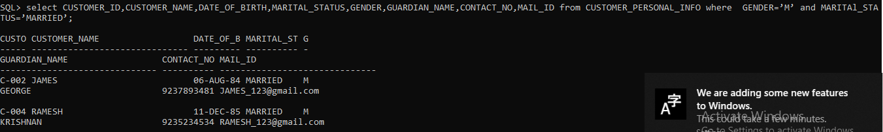

**9.*Write a query which will display the customer id, customer name, guardian name, reference account holders name of the customers**

**who are referenced / referred by their 'FRIEND'.**

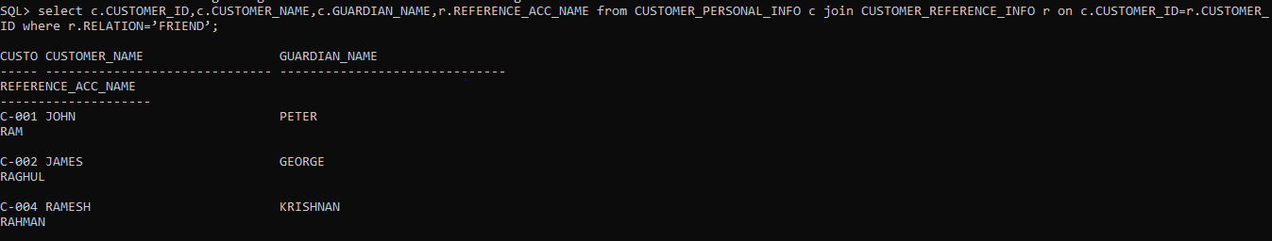select c.CUSTOMER_ID,c.CUSTOMER_NAME,c.GUARDIAN_NAME,r.REFERENCE_ACC_NAME from CUSTOMER_PERSONAL_INFO c join CUSTOMER_REFERENCE_INFO r on c.CUSTOMER_ID=r.CUSTOMER_ID where r.RELATION=’FRIEND’;

**10.*Write a query to display the customer id, account number and interest amount in the below format with INTEREST_AMT as alias name**

**Sort the result based on the INTEREST_AMT in ascending order. <BR/>Example:**

**$5<BR/>Hint: Need to prefix $ to interest amount and round the result without decimals.**

select CUSTOMER_ID,ACCOUNT_NO,(‘$’ || round(INTEREST)) as INTEREST_AMT from ACCOUNT_INFO order by INTEREST_AMT;

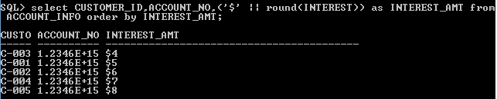

**11.*Write a query which will display the customer id, customer name, account no, account type, activation date,**

**bank name whose account will be activated on '10-APR-2012'**

select c.CUSTOMER_ID,c.CUSTOMER_NAME,a.ACCOUNT_NO,a.ACCOUNT_TYPE,a.ACTIVATION_DATE,b.BANK_NAME from CUSTOMER_PERSONAL_INFO c join ACCOUNT_INFO a on c.CUSTOMER_ID=a.CUSTOMER_ID join BANK_INFO b on b.IFSC_CODE=a.IFSC_CODE where a.ACTIVATION_DATE = ’10-APR-2012’;

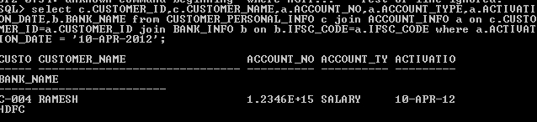

**12.*Write a query which will display account number, customer id, customer name, bank name, branch name, ifsc code**

**, citizenship, interest and initial deposit amount of all the customers.**

select a.ACCOUNT_NO,c.CUSTOMER_ID,c.CUSTOMER_NAME,b.BANK_NAME,b.BRANCH_NAME,b.IFSC_CODE,c.CITIZENSHIP,a.INTEREST,a.INITIAL_DEPOSIT from CUSTOMER_PERSONAL_INFO c join ACCOUNT_INFO a on c.CUSTOMER_ID=a.CUSTOMER_ID join BANK_INFO b on a.IFSC_CODE=b.IFSC_CODE;

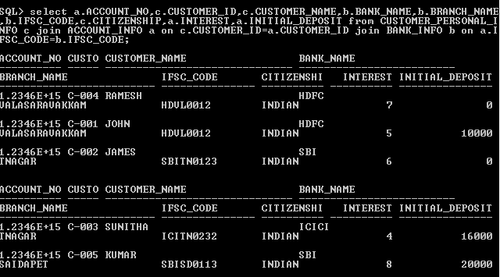

**13.*Write a query which will display customer id, customer name, date of birth, guardian name, contact number,**

**mail id and reference account holder's name of the customers who has submitted the passport as an identification document.**

select c.CUSTOMER_ID,c.CUSTOMER_NAME,c.DATE_OF_BIRTH,c.GUARDIAN_NAME,c.CONTACT_NO,c.MAIL_ID,r.REFERENCE_ACC_NAME from CUSTOMER_PERSONAL_INFO c join CUSTOMER_REFERENCE_INFO r on c.CUSTOMER_ID=r.CUSTOMER_ID where c.IDENTIFICATION_DOC_TYPE=’PASSPORT’;

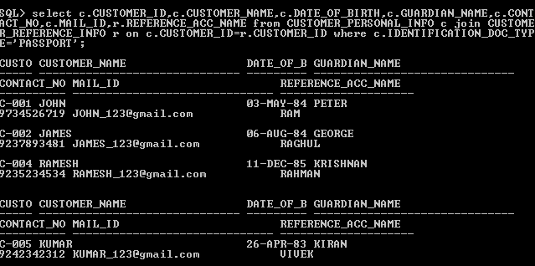

**14.*Write a query to display the customer id, customer name, account number, account type, initial deposit,**

**interest who have deposited maximum amount in the bank.**

select c.CUSTOMER_ID,c.CUSTOMER_NAME,a.ACCOUNT_NO,a.ACCOUNT_TYPE,a.INITIAL_DEPOSIT,a.INTEREST from CUSTOMER_PERSONAL_INFO c join ACCOUNT_INFO a on c.CUSTOMER_ID=a.CUSTOMER_ID where a.INITIAL_DEPOSIT=(select MAX(INITIAL_DEPOSIT) from ACCOUNT_INFO);

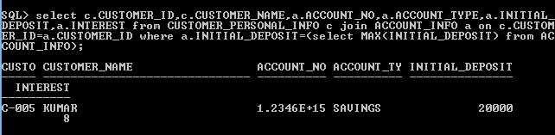

**15.*Write a query to display the customer id, customer name, account number, account type, interest, bank name**

**and initial deposit amount of the customers who are getting maximum interest rate.**

select c.CUSTOMER_ID,c.CUSTOMER_NAME,a.ACCOUNT_NO,a.ACCOUNT_TYPE, a.INTEREST,b.BANK_NAME, a.INITIAL_DEPOSIT from CUSTOMER_PERSONAL_INFO c join ACCOUNT_INFO a on c.CUSTOMER_ID=a.CUSTOMER_ID join BANK_INFO b on a.IFSC_CODE=b.IFSC_CODE where a.INTEREST=(select MAX(INTEREST) from ACCOUNT_INFO);

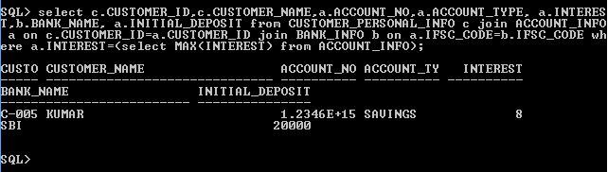

**16.Write a query to display the customer id, customer name, account no, bank name, contact no**

**and mail id of the customers who are from BANGALORE.**

select c.CUSTOMER_ID,c.CUSTOMER_NAME,a.ACCOUNT_NO,b.BANK_NAME,c.CONTACT_NO,c.MAIL_ID from CUSTOMER_PERSONAL_INFO c join ACCOUNT_INFO a on c.CUSTOMER_ID=a.CUSTOMER_ID join BANK_INFO b on a.IFSC_CODE=b.IFSC_CODE where c.ADDRESS like ‘%BANGALORE’;

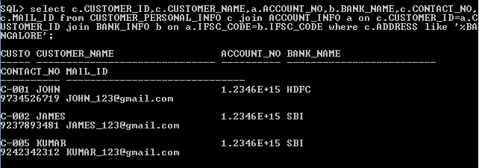

**17.Write a query which will display customer id, bank name, branch name, ifsc code, registration date,**

**activation date of the customers whose activation date is in the month of march (March 1'st to March 31'st).**

select a.CUSTOMER_ID,b.BANK_NAME,b.BRANCH_NAME,b.IFSC_CODE,a.REGISTRATION_DATE,a.ACTIVATION_DATE from ACCOUNT_INFO a join BANK_INFO b on a.IFSC_CODE=b.IFSC_CODE where a.ACTIVATION_DATE like ‘%MAR%’;

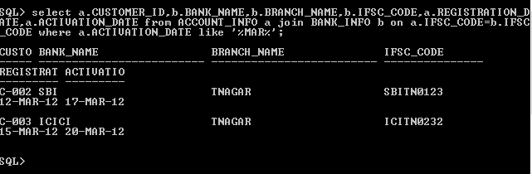

**18.Write a query which will calculate the interest amount and display it along with customer id, customer name,**

**account number, account type, interest, and initial deposit amount.<BR>Hint :Formula for interest amount,**

**calculate: ((interest/100) * initial deposit amt) with column name 'interest_amt' (alias)**

select c.CUSTOMER_ID,c.CUSTOMER_NAME,a.ACCOUNT_NO,a.ACCOUNT_TYPE,a.INTEREST,a.INITIAL_DEPOSIT,((a.INTEREST/100)*a.INITIAL_DEPOSIT) as INTEREST_AMT from CUSTOMER_PERSONAL_INFO c join ACCOUNT_INFO a on c.CUSTOMER_ID=a.CUSTOMER_ID;

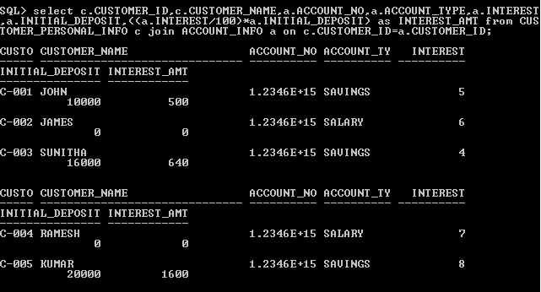

**19.Write a query to display the customer id, customer name, date of birth, guardian name, contact number,**

**mail id, reference name who has been referenced by 'RAGHUL'.**

select c.CUSTOMER_ID,c.CUSTOMER_NAME,c.DATE_OF_BIRTH,c.GUARDIAN_NAME,c.CONTACT_NO,c.MAIL_ID,r.REFERENCE_ACC_NAME from CUSTOMER_PERSONAL_INFO c join CUSTOMER_REFERENCE_INFO r on c.CUSTOMER_ID=r.CUSTOMER_ID where r.REFERENCE_ACC_NAME=’RAGHUL’;

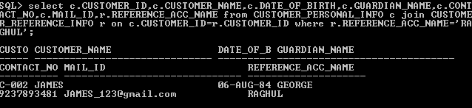

**20."Write a query which will display the customer id, customer name and contact number with ISD code of**

**all customers in below mentioned format. Sort the result based on the customer id in descending order.**

**<BR>Format for contact number is :**

**<br/> ""+91-3digits-3digits-4digits""**

**<br/> Example: +91-924-234-2312**

**<br/> Use ""CONTACT_ISD"" as alias name."**

select CUSTOMER_ID,CUSTOMER_NAME,(‘+91’ || ‘-‘ || substr(CONTACT_NO,0,3) || ‘-‘ || substr(CONTACT_NO,4,0) || ‘-‘ || substr(CONTACT_NO,-4)) as CONTACT_ISD from CUSTOMER_PERSONAL_INFO;

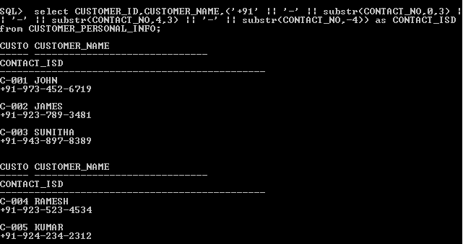

**21.Write a query which will display account number, account type, customer id, customer name, date of birth, guardian name,**

**contact no, mail id , gender, reference account holders name, reference account holders account number, registration date,**

**activation date, number of days between the registration date and activation date with alias name "NoofdaysforActivation",**

**bank name, branch name and initial deposit for all the customers.**

select a.ACCOUNT_NO,a.ACCOUNT_TYPE,c.CUSTOMER_ID,c.CUSTOMER_NAME,c.DATE_OF_BIRTH,c.GUARDIAN_NAME,c.CONTACT_NO,c.MAIL_ID,c.GENDER,r.REFERENCE_ACC_NAME,r.REFERENCE_ACC_NO,(a.ACTIVATION_DATE-a.REGISTRATION_DATE) as NoofdaysforActivation,b.BANK_NAME,b.BRANCH_NAME,a.INITIAL_DEPOSIT from CUSTOMER_PERSONAL_INFO c join ACCOUNT_INFO a on c.CUSTOMER_ID=a.CUSTOMER_ID join BANK_INFO b on a.IFSC_CODE=b.IFSC_CODE join CUSTOMER_REFERENCE_INFO r on c.CUSTOMER_ID=r.CUSTOMER_ID;

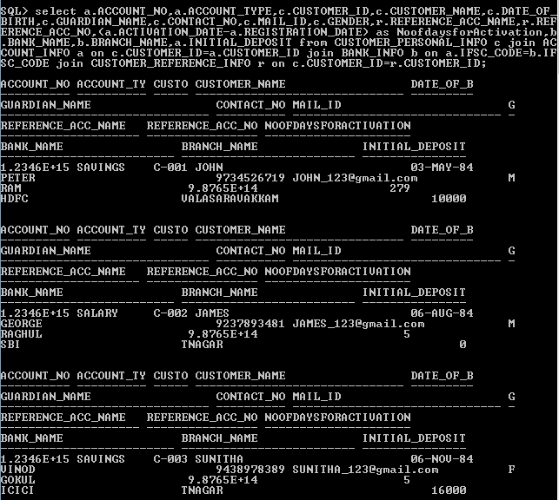

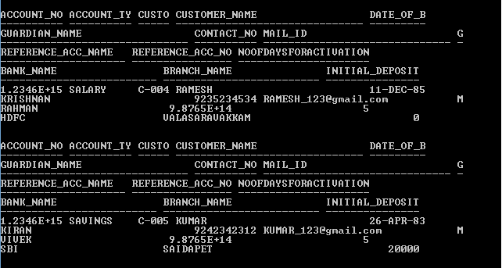

**22."Write a query which will display customer id, customer name, guardian name, identification doc type,**

**reference account holders name, account type, ifsc code, bank name and current balance for the customers**

**who has only the savings account.**

**<br/>Hint: Formula for calculating current balance is add the intital deposit amount and interest**

**and display without any decimals. Use ""CURRENT_BALANCE"" as alias name."**

select c.CUSTOMER_ID,c.CUSTOMER_NAME,c.GUARDIAN_NAME,c.IDENTIFICATION_DOC_TYPE,r.REFERENCE_ACC_NAME,a.ACCOUNT_TYPE,a.IFSC_CODE,b.BANK_NAME,(round(a.INITIAL_DEPOSIT+a.INTEREST))as CURRENT_BALANCE from CUSTOMER_PERSONAL_INFO c join ACCOUNT_INFO a on c.CUSTOMER_ID=a.CUSTOMER_ID join BANK_INFO b on a.IFSC_CODE=b.IFSC_CODE join CUSTOMER_REFERENCE_INFO r on c.CUSTOMER_ID=r.CUSTOMER_ID where a.ACCOUNT_TYPE=’SAVINGS’;

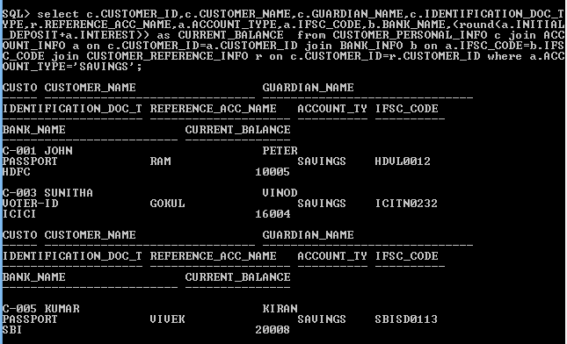

**23."Write a query which will display the customer id, customer name, account number, account type, interest, initial deposit;**

**<br/>check the initial deposit,<br/> if initial deposit is 20000 then display ""high"",<br/> if initial deposit is 16000 display 'moderate'**

**,<br/> if initial deposit is 10000 display 'average', <br/>if initial deposit is 5000 display 'low', <br/>if initial deposit is 0 display**

**'very low' otherwise display 'invalid' and sort by interest in descending order.<br/>**

**Hint: Name the column as ""Deposit_Status"" (alias).**

**<br/>Strictly follow the lower case for strings in this query."**

select c.CUSTOMER_ID,c.CUSTOMER_NAME,a.ACCOUNT_NO,a.ACCOUNT_TYPE,a.INTEREST,a.INITIAL_DEPOSIT,(CASE a.INITIAL_DEPOSIT

WHEN 20000 THEN ‘high’

WHEN 16000 THEN ‘moderate’

WHEN 10000 THEN ‘average’

WHEN 5000 THEN ‘low’

WHEN 0 THEN ‘very low’

ELSE ‘invalid’

END) as DEPOSIT_STATUS from CUSTOMER_PERSONAL_INFO c join ACCOUNT_INFO a on c.CUSTOMER_ID=a.CUSTOMER_ID;

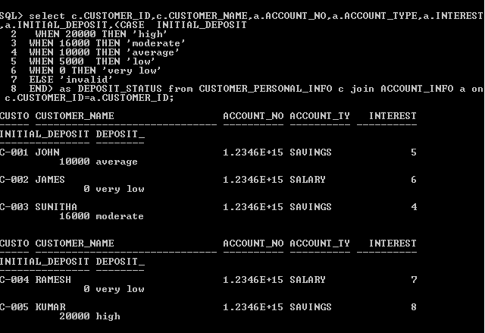

**24."Write a query which will display customer id, customer name, account number, account type, bank name, ifsc code, initial deposit amount**

**and new interest amount for the customers whose name starts with ""J"".**

**<br/> Hint: Formula for calculating ""new interest amount"" is**

**if customers account type is savings then add 10 % on current interest amount to interest amount else display the current interest amount.**

**Round the new interest amount to 2 decimals.<br/> Use ""NEW_INTEREST"" as alias name for displaying the new interest amount.**

**<br/>Example, Assume Jack has savings account and his current interest amount is 10.00, then the new interest amount is 11.00 i.e (10 + (10 * 10/100)).**

select c.CUSTOMER_ID,c.CUSTOMER_NAME,a.ACCOUNT_NO,a.ACCOUNT_TYPE,b.BANK_NAME,b.IFSC_CODE,a.INITIAL_DEPOSIT,(CASE a.ACCOUNT_TYPE

WHEN ‘SAVINGS’ THEN round((1.1*a.INTEREST),2)

ELSE round(a.INTEREST,2)

END)

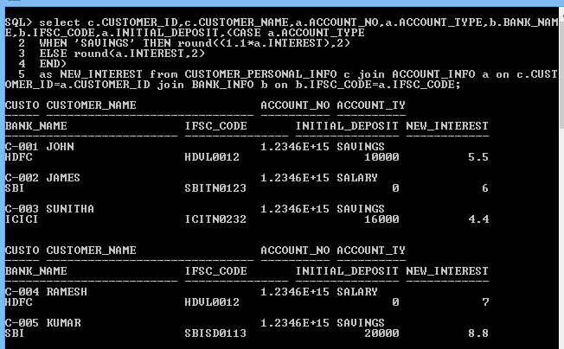as NEW_INTEREST from CUSTOMER_PERSONAL_INFO c join ACCOUNT_INFO a on c.CUSTOMER_ID=a.CUSTOMER_ID join BANK_INFO b on b.IFSC_CODE=a.IFSC_CODE;

**25.Write query to display the customer id, customer name, account no, initial deposit, tax percentage as calculated below.**

**<BR>Hint: <BR>If initial deposit = 0 then tax is '0%'<BR>If initial deposit &lt;= 10000 then tax is '3%'**

**<BR>If initial deposit &gt; 10000 and initial deposit &lt; 20000 then tax is '5%' <BR>If initial deposit &gt;= 20000 and**

**initial deposit&lt;=30000 then tax is '7%' <BR>If initial deposit &gt; 30000 then tax is '10%' <BR>Use the alias name 'taxPercentage'**

select c.CUSTOMER_ID,c.CUSTOMER_NAME,a.ACCOUNT_NO,a.INITIAL_DEPOSIT,

(case a.INITIAL_DEPOSIT

WHEN 0 THEN ‘0%’

WHEN 10000 THEN ‘3%’

WHEN 20000 THEN ‘5%’

WHEN 30000 THEN ‘7%’

ELSE ‘10%’

END) as TAXPERCENTAGE from CUSTOMER_PERSONAL_INFO c join ACCOUNT_INFO a on c.CUSTOMER_ID=a.CUSTOMER_ID;

